Vol. 3, No. 1, June 2025.
DOI: https://doi.org/10.35914/mathstat.v2i2.195

Prediction of Domestic and Foreign Tourist Visits Using the Long Short-Term Memory (LSTM) Method

Tria Afnidia¹, Novi Herlina Putri², Siti Soraya³, Firmansyah⁴
^{1,2,3}Department of Computer Science, Universitas Bumigora, Indonesia
*Corresponding email : sitisorayaburhan@universitasbumigora.ac.id

ABSTRACT
The tourism sector makes an important contribution to supporting regional economic growth. Among the various provinces in Indonesia, West Nusa Tenggara (NTB) stands out as one of the main tourist destinations that has shown a fairly rapid increase in the number of tourist visits in recent years. This study uses Adam optimization and gradient clipping techniques to predict domestic and foreign tourist visits in NTB using the Long Short-Term Memory (LSTM) method. Monthly historical data for the period 2014–2023 from the NTB Tourism Office was processed through Min-Max Scaling normalization and divided with a ratio of 70:30 and 80:20. The LSTM model with a 4-layer architecture (2 LSTM layers with 50 units and 2 Dense layers) was tested using the Root Mean Squared Error (RMSE) metric. Based on the results obtained, the best configuration was shown at a ratio of 70:30 with 200 epochs, producing the lowest RMSE of 66.70 on the training data and 33.24 on the testing data. This implies that the model can capture seasonal patterns and visit trends, although it is less responsive to outliers such as natural disasters. This implementation provides a basis for tourism capacity planning and data-based destination management.

Keyword: Adam Optimizer, Long Short-Term Memory, Prediction, Time Series, Tourist
Article History:
Received, 14-10-2024; Revised, 12-11-2024; Accepted, 19-11-2024.

Introduction

West Nusa Tenggara (NTB) Province, also known as Sasambo, is experiencing rapid growth in the tourism sector. This progress is driven by a strategic geographical location with a row of small islands (gili), a supportive tropical climate, and the unique culture of the Sasak Tribe, making NTB an area with great potential to be developed into an international-class tourist destination (Soraya, Fitriana Aziza, et al., 2024). NTB Province has great opportunities for tourism development, because in addition to acting as a center for travel and development activities, this region is also the main gateway to the eastern region of Indonesia. (Rizal & Soraya, 2018).

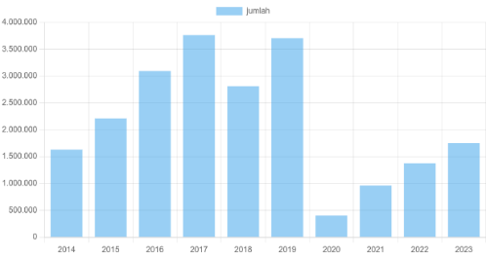

Figure 1. Visits of Domestic and Foreign Tourists in 2014-2023

Based on data from the NTB Province Tourism Office from 2014-2023 with the percentage of domestic and foreign tourist visits in 2014 at 7.24%. 2015 – 2017 experienced a very significant increase until 2018 experienced a slight decrease due to the earthquake disaster in mid-2018. However, in 2019 tourism recovery after the earthquake increased to 16.46%. In contrast, in 2020 the percentage of tourist visits experienced a very significant decrease to 1.78%. The number of foreign tourists coming to Indonesia has fallen drastically along with the reduction in international flights. Domestic tourists have also experienced a very drastic decline since the pandemic and worsened with the implementation of social and physical-distancing (Amrita et al., 2021). In 2022-2023, after the COVID-19 pandemic, there has been a gradual increase in the number of tourists. When the Mandalika Circuit was built, the number of foreign tourist visitors increased rapidly.
The level of tourist visits to NTB Province is influenced by various factors, both internal and external. One of the key external factors is the exchange rate. The exchange rate is a primary consideration for individuals planning a trip, as it directly relates to expenses and prices in the tourism sector. The higher the foreign exchange rate against the rupiah, the greater the interest of citizens of that country to travel, as it is considered more financially affordable (Hendayanti & Nurhidayati, 2020). On the other hand, internal factors such as the availability and management of accommodation, perceptions of security levels, and stable social and political conditions in an area also play a role in determining tourist choices. Information or news about unfavorable security situations can create a negative impression of the destination, ultimately impacting the decline in interest to visit (Soraya, Rahima, et al., 2024).
Over time, fluctuations in the number of tourists each day can impact the growth and revenue of tourist destinations. If there is a surge in the number of visitors, this has the potential to create challenges for tourism managers in providing optimal services and facilities for tourists (Chen et al., 2016). Therefore, to overcome these problems, tourism managers need to have the ability to predict the number of tourist visits in the future through forecasting methods. Forecasting is an important part of the decision-making process, because the success of a decision is often influenced by factors that are not yet visible at the time the decision is made. In general, forecasting serves as a support tool in designing more precise, efficient, and effective planning (Hirzi et al., 2023).
Deep learning is a modern learning approach known for its high performance and ability to form effective models in processing data optimally (Zamachsari & Puspitasari, 2021). Deep learning is a branch of machine learning that utilizes many layers to process non-linear information. One of the algorithms in deep learning is Long Short Term Memory (LSTM), which was developed from Recurrent Neural Network (RNN) and designed to overcome the main limitations of RNN, namely its inability to manage long-term sequential data, especially in time-series data processing (Sulistianingsih & Martono, 2024).
Time series is an analysis method that considers the influence of time sequentially. Data collected based on time order, such as hours, days, weeks, months, quarters, to years, can be analyzed using this approach. Information from time series can be used as a basis for decision-making to predict future events. Time series analysis is not limited to one variable (univariate), but can also be applied to more than one variable (multivariate) (Nguyen et al., 2023)
This research is relevant to research (Rizal & Soraya, 2018) which discusses the prediction of tourist visits to Lombok Island using the Recurrent Neural Network Long Short Term Memory method, one form of Recurrent Neural Network. In this study, three types of prediction models were developed, namely LSTM regression, LSTM based on sliding window, and LSTM with multi time steps. The results obtained show that each model has different performance levels, and no single model provides the most optimal results consistently on both training and testing data. Based on this, it was concluded that further development is needed, such as utilizing more adaptive training algorithms and initial weight optimization, so that the training process is more efficient and the prediction results are more accurate.
This research focuses on the application of the Adam Optimizer algorithm and gradient clipping technique to improve the accuracy and stability of the LSTM model in predicting the number of tourist visits to the Province of West Nusa Tenggara. The data used is in the form of monthly historical data that includes the number of domestic and foreign tourist visits. The aim of this research is to analyze the ability of the LSTM model in predicting the number of tourist visits to the Province of West Nusa Tenggara, and to provide a more accurate picture of future visit trends, which can be used as a basis for planning management and development strategies for the tourism sector.

Method

This research uses a prediction approach based on the Long Short-Term Memory (LSTM) algorithm to predict the number of domestic and foreign tourist visits to the Province of Nusa Tenggara Barat. The LSTM model was developed using the Adam Optimizer training algorithm and gradient clipping techniques to maintain stability and increase accuracy during the training process. This model is designed to recognize seasonal patterns and long-term fluctuations in monthly tourist visit data from 2014 to 2023.
This research consists of several main stages which include data preprocessing, LSTM model formation, training with optimization algorithms, and evaluation of prediction results (Ashari & Suhendar, 2024) (Sulistianingsih & Martono, 2024). The research flowchart can be seen in Figure 2
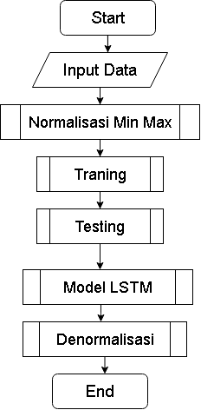
Figure 2. LSTM Model Flowchart
- Preprocessing
The data preprocessing stage in this research uses Min-Max Scaling. Min-Max Scaling is a data normalization technique that transforms numerical values into the range [0,1] so that all features have a uniform scale, thus increasing stability and convergence speed during the model training process. Min-max scaling normalization is carried out using the following equation (1):

$x^{'}= \frac{x-x_{min}}{x_{max}-x_{min}}$ (1)

where:
$x^'$ = data value after normalization
$x$ = original data value
$x_min$ = minimum value in the feature
$x_max$ = maximum value in the feature

- Long Short-Term Memory (LSTM)
LSTM (Long Short-Term Memory) is a type of architecture developed from RNN (Recurrent Neural Network) with the aim of overcoming constraints that often arise in traditional RNN models, such as exploding gradient and vanishing gradient problems when processing data sequences over long periods of time. Because of its ability to maintain long-term information, LSTM is very suitable for prediction and classification tasks related to time series data (Li et al., 2024).

Figure 3. LSTM Architecture
Figure 3 is a visualization of the LSTM architecture which consists of an input layer, hidden layers, and output layers. The input layer functions to receive data from outside and send it to the hidden layer for further processing. Inside the hidden layer there is a memory cell, where each cell has three main components called gates, namely the input gate, forget gate, and output gate. The input gate plays a role in regulating the amount of new information that enters the cell memory, so that unnecessary information can be filtered out. The forget gate determines how much old information needs to be discarded so that the memory is not burdened. The output gate functions to regulate the amount of information from memory that will be used as output and forwarded to the next process. After the entire process in the hidden layer is complete, the results will be forwarded to the output layer, which plays a role in producing the final output from the network based on the information that has been learned (Wiranda & Sadikin, 2019).

- Training the LSTM model using Adam Optimizer and the Gradient Clipping technique
In the training stage, the Long Short-Term Memory (LSTM) model is trained to recognize time series patterns based on normalized tourist visit data. The training process is carried out iteratively using the Adam Optimizer optimization algorithm, which is an adaptive optimization algorithm that combines the advantages of RMSProp and Momentum-based Gradient Descent which allows the model to achieve faster and more stable convergence (Schmidhuber, 2015). The Adam algorithm updates weights using estimates of the first (momentum) and second (variance) moments of the gradients. The formula for updating the parameter θ at iteration t is as follows (Tandean Johan et al., 2023):
Source: (Mahajaya et al., 2024)
$θ_{t}= θ_{t-1}-α\frac{{\hat{m}}_{t}}{\sqrt{{\hat{v}}_{t}+ ϵ}}$ (2)

where :
$θ_{t}$ = New weight
${\hat{m}}_{t}$ = Average gradient
${\hat{v}}_{t}$ = Average squared gradient
α = learning rate
$ϵ$ = Constant

To maintain training stability, the Gradient Clipping technique is also applied which aims to limit the maximum value of the gradient. This technique prevents the gradient value from becoming too large (exploding gradient) which can cause learning failure or the model parameters to become unstable. The combination of Adam Optimizer and Gradient Clipping produces a more efficient and accurate training process in learning tourist visit patterns from time series data.

- Model Evaluation Using RSME
After the training is complete, the model's performance is evaluated using the Root Mean Squared Error (RMSE) metric. Root Mean Squared Error (RMSE) is the square root of the average of the squared differences between the actual data and the predicted results (Almuhaini & Sultana, 2023). In other words, RMSE can be considered as the standard deviation of the error values. This value indicates how accurately the model estimates the data, or in other words, measures how close the predicted result line is to the actual data point set.
$RSME= \sqrt{\frac{1}{n}\sum_{i=1}^{n}{{\left(y_{i}-{\hat{y}}_{i}\right)}^{2}}}$ (3)
where:
$n$ = Number of predictions
$y_i$ = Observed value
${\hat{y}}_{i}$ = Predicted value

Result and Discussion

This chapter presents the results of training and evaluating the Long Short-Term Memory (LSTM) model used to predict the total number of tourist visits to the Province of Nusa Tenggara Barat. The data used includes the number of domestic and foreign tourist visits from 2014 to 2023, which have been summed into a single total visits per month variable. The LSTM model was trained using time series data with a horizon of 12 months (time steps) as input. Testing was carried out by configuring different epoch and training and testing data ratios. The number of epochs applied were 100 and 200. The composition of training and testing data used was 70:30 and 80:20.
Table 1. Prediction Results
Data Ratio | Epoch | RSME Training | RSME Testing
70:30 | 100 | 83.89 | 36.58
70:30 | 200 | 66.70 | 33.24
80:20 | 100 | 116.63 | 57.05
80:20 | 200 | 104.59 | 41.97
Table 1 presents the prediction results of the LSTM model with various combinations of data ratios and number of epochs. Each configuration is tested to see its effect on the RMSE value, both on training and testing data.
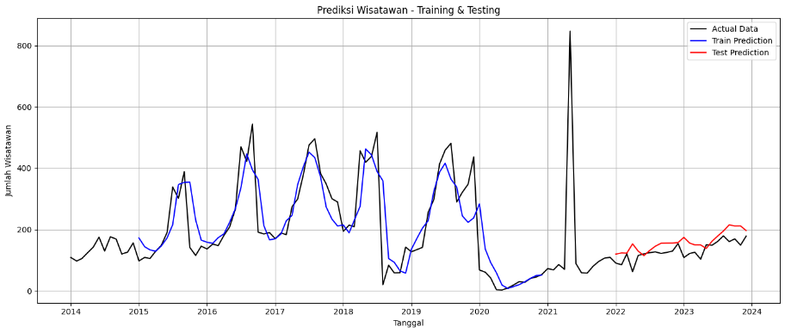
Figure 4. Prediction Result Graph for 70:30 Data Ratio with 100 Epochs
Figure 4 displays a graph of the training and testing results carried out with a data ratio of 70:30 and a number of epochs of 100. This configuration produces an RMSE value of 83.89 on the training data and 36.58 on the testing data. Although the model has begun to recognize data patterns, the prediction results are not yet fully stable. Some deviations from the actual values are still visible in the graph.
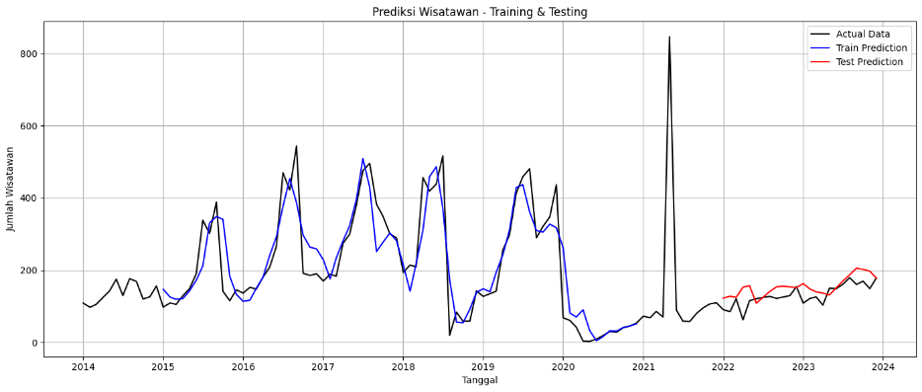
Figure 5. Prediction Result Graph for 70:30 Data Ratio with 200 Epochs
Figure 5 displays a graph of the training and testing results carried out with a data ratio of 70:30 and a number of epochs of 200. This configuration produces the lowest RMSE value, which is 66.70 on the training data and 33.24 on the testing data. The model shows the most optimal performance in learning tourist visit patterns. This graph displays prediction results that are closest to the actual values compared to other configurations.
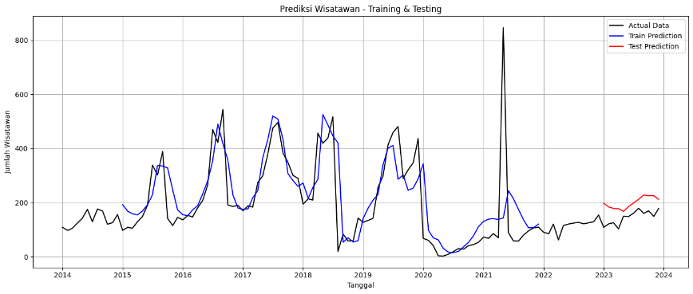
Figure 6. Prediction Result Graph for 80:20 Data Ratio with 100 Epochs
Figure 6 displays a graph of the training and testing results carried out with a data ratio of 80:20 and a number of epochs of 100. This configuration produces an RMSE value of 116.63 on the training data and 57.05 on the testing data. The model shows less than optimal performance due to the smaller amount of training data. This graph shows prediction results that tend to deviate from the actual values.
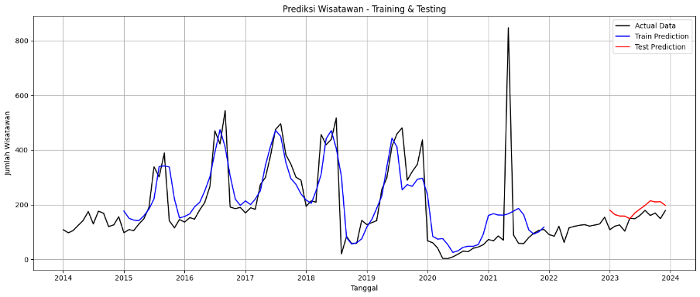
Figure 7. Prediction Result Graph for 80:20 Data Ratio with 200 Epochs
Figure 7 displays a graph of the training and testing results carried out with a data ratio of 80:20 and a number of epochs of 200. This configuration produces an RMSE value of 104.59 on the training data and 41.93 on the testing data. Although there is an increase compared to the previous epoch, the prediction results are still not as accurate as the 70:30 ratio configuration.
The comparison results show that the data ratio combination of 70:30 with 200 epochs provides the best performance in predicting the number of domestic and foreign tourist visits in the Province of Nusa Tenggara Barat. This is indicated by the lowest RMSE value of 66.70 for training data and 33.24 for testing data, which shows the smallest prediction error rate compared to other combinations. Meanwhile, the 80:20 data ratio produces a higher RMSE value, both at epoch 100 and 200, so it can be concluded that the use of larger training data and a larger number of epochs provides more accurate prediction results in the application of the LSTM method with the Adam Optimizer algorithm and Gradient Clipping technique.
Based on the prediction results, this study is in line with the results of research [10] which also shows that the LSTM method is able to effectively identify seasonal patterns and fluctuations in the number of tourist visits. Although the study did not use advanced optimization techniques such as Adam Optimizer and gradient clipping, the accuracy results show that LSTM is a potential approach in modeling time series data of tourist visits. With the addition of Adam Optimizer and gradient clipping optimization techniques, the prediction results in this study show an increase in accuracy as indicated by a lower RMSE value, especially in the 70:30 data ratio configuration and 200 epochs.

Conclusion

Based on the research results, it can be concluded that the LSTM model with Adam optimization and gradient clipping technique is able to predict the total number of tourists visiting the Province of Nusa Tenggara Barat with a good level of accuracy. The best configuration was obtained at a training and testing data ratio of 70:30 with 200 epochs, resulting in the lowest RMSE value of 66.70 on training data and 33.24 on testing data. This model successfully identifies seasonal patterns and tourist visit trends, although it still has limitations in responding to anomalies such as natural disasters or pandemics. The gradient clipping technique has proven effective in stabilizing the model training process. The results of this study can be the basis for tourism managers in NTB in developing tourism destination development strategies. For further research, it is recommended to integrate external variables such as economic factors and tourism policies to improve prediction accuracy, as well as develop a hybrid model that combines LSTM with other methods to capture more complex data patterns.

References
Almuhaini, S. H., & Sultana, N. (2023). Bayesian-Optimization-Based Long Short-Term Memory (LSTM) Super Learner Approach for Modeling Long-Term Electricity Consumption. Sustainability (Switzerland), 15(18). https://doi.org/10.3390/su151813409
Amrita, N. D. A., Handayani, M. M., & Erynayati, L. (2021). Pengaruh Pandemi Covid-19 Terhadap Pariwisata Bali. Jurnal Manajemen Dan Bisnis Equilibrium, 7(2), 246–257. https://doi.org/10.47329/jurnal_mbe.v7i2.824
Ashari, Y., & Suhendar, A. (2024). Implementasi Algoritma Long Short-Term Memory (Lstm) Untuk Memprediksi Harga Beras Di Jawa Tengah Berdasarkan Cuaca. Djtechno: Jurnal Teknologi Informasi, 5(3), 624–636. https://doi.org/10.46576/djtechno.v5i3.5136
Chen, C.-C., Lai, Y.-H. (Rebecca), Petrick, J. F., & Lin, Y.-H. (2016). Tourism between Divided Nations: An examination of Stereotyping on Destination Image. Tourism Management, 55, 25–36. https://doi.org/10.1016/j.tourman.2016.01.012
Hendayanti, N. P. N., & Nurhidayati, M. (2020). Perbandingan Metode Seasonal Autoregressive Integrated Moving Average (SARIMA) dengan Support Vector Regression (SVR) dalam Memprediksi Jumlah Kunjungan Wisatawan Mancanegara ke Bali. Jurnal Varian, 3(2), 149–162. https://doi.org/10.30812/varian.v3i2.668
Hirzi, R. H., Hidayaturrohman, U., Kertanah, K., Amaly, M. H., & Satriawan, R. (2023). Prediksi Jumlah Wisatawan Menggunakan Metode Random Forest, Single Exponential Smoothing dan Double Exponential Smoothing di Provinsi NTB. Jambura Journal of Probability and Statistics, 4(1), 47–55. https://doi.org/10.34312/jjps.v4i1.17088
Li, G., Wang, Y., Xu, C., Wang, J., Fang, X., & Xiong, C. (2024). BO-STA-LSTM: Building energy prediction based on a Bayesian optimized spatial-temporal attention enhanced LSTM method. Developments in the Built Environment, 18(May), 100465. https://doi.org/10.1016/j.dibe.2024.100465
Nguyen, H. A. D., Ha, Q. P., Duc, H., Azzi, M., Jiang, N., Barthelemy, X., & Riley, M. (2023). Long Short-Term Memory Bayesian Neural Network for Air Pollution Forecast. IEEE Access, 11(March), 35710–35725. https://doi.org/10.1109/ACCESS.2023.3265725
Rizal, A. A., & Soraya, S. (2018). Multi Time Steps Prediction dengan Recurrent Neural Network Long Short Term Memory. MATRIK : Jurnal Manajemen, Teknik Informatika Dan Rekayasa Komputer, 18(1), 115–124. https://doi.org/10.30812/matrik.v18i1.344
Schmidhuber, J. (2015). Deep Learning. In Scholarpedia (Vol. 10, Issue 11). https://doi.org/10.4249/scholarpedia.32832
Soraya, S., Fitriana Aziza, I., Rizky, M., Juanda, U., Primajati, G., & Rahima, P. (2024). Peramalan Jumlah Kunjungan Wisatawan di Provinsi Nusa Tenggara Barat (NTB) Menggunakan Metode Arima Box-Jenkins. VARIANSI: Journal of Statistics and Its Application on Teaching and Research, 6(01), 35–43. https://doi.org/10.35580/variansiunm150
Soraya, S., Rahima, P., Primajati, G., & Nurhidayati, M. (2024). Forecasting Tourist Visits During The Covid-19 Pandemic and MotoGP Events Using The Sarima Method. 7(3), 235–244. https://doi.org/10.12962/j27213862.v7i3.20139
Sulistianingsih, N., & Martono, G. H. (2024). Comparative Study on Stock Movement Prediction Using Hybrid Deep Learning Model. ECTI Transactions on Computer and Information Technology, 18(4), 531–542. https://doi.org/10.37936/ecti-cit.2024184.256303
Tandean Johan, Indrawan Rhadi, Intan Indo, & Arifin Suci Ramadhani. (2023). Pengaruh Penerapan Stochastic Gradient Descent Dan Adam Optimizer Pada Hyperparameter Tuning Untuk Klasifikasi Penyakit Tanaman Ubi Kayu. Jurnal Dipanegara Komputer Teknik Informatika, XVI(1), 80–90.
Wiranda, L., & Sadikin, M. (2019). Penerapan Long Short Term Memory pada Data Time Series untuk Memprediksi Penjualan Produk PT. Metiska Farma. Jurnal Nasional Pendidikan Teknik Informatika (JANAPATI), 8(3), 184–196.
Zamachsari, F., & Puspitasari, N. (2021). Penerapan Deep Learning dalam Deteksi Penipuan Transaksi Keuangan Secara Elektronik. Jurnal RESTI (Rekayasa Sistem Dan Teknologi Informasi), 5(2), 203–212. https://doi.org/10.29207/resti.v5i2.2952

