Vol. 3, No. 1, June 2025.
DOI: https://doi.org/10.35914/mathstat.v2i2.195

Analysis of Factors Influencing Chili Production Using the Spatial Regression Method

Laraswati Ananda¹, Riski Gusnayanti², Muji Ratmaji³, Siti Soraya⁴, Firmansyah⁵
^{1,2,3}Department of Computer Science, Universitas Bumigora, Indonesia
*Corresponding email : sitisorayaburhan@universitasbumigora.ac.id

ABSTRACT
Chili pepper production in West Nusa Tenggara is the second largest producer in Indonesia. However, the distribution of production still shows a significant imbalance between regions. This imbalance can affect the stability of supply and prices both locally and nationally. This study aims to examine the factors that influence chili pepper production in NTB using the spatial regression method. The data used are secondary data from agricultural statistics in 2024, which cover ten districts/cities. The SEM model was chosen because it can identify the effects that occur between geographically close regions, which are often not visible in traditional regression models. The results of the analysis show that the area of ​​harvested land and the level of chili pepper productivity have a significant effect on the total production at a real level of 10%, with coefficients of 96.6132 and 44,385.5, respectively. The lambda value reaching 1.6667 provides support for evidence of positive spatial autocorrelation between regions. The SEM model also showed a lower AIC value (316.58) compared to the classical regression model, indicating that this model is more efficient and accurate.

Keyword: Agriculture, Cayenne Pepper, Chili, Economic, Production, Spatial Error Model
Article History:
Received, 14-10-2024; Revised, 12-11-2024; Accepted, 19-11-2024.

Introduction

The agricultural sector is a vital part of the Indonesian economy, with many people working as farmers due to the natural conditions that support national economic development. This sector is renowned for producing high-quality agricultural products, making Indonesia known as an agrarian nation with significant capacity in this area (Manggala & Boedi, 2018). Agricultural products significantly impact the Indonesian economy by creating jobs, offering a variety of food choices, helping to alleviate poverty, and generating revenue for the state (Siswanto et al., 2020). Horticultural crops are a crucial component of the agricultural sector. Horticultural crops contribute significantly to ensuring food security and supporting Indonesia's future economic growth (Deviani et al., 2019).
Chili plants, particularly cayenne peppers, are a crucial and highly sought-after agricultural commodity in Indonesia. There are around 20 types of chili, but generally Indonesian people only know four types, namely cayenne pepper, large chili, curly chili, and paprika (Nisa & Ambarwati, 2022) West Nusa Tenggara is the second largest province in producing cayenne pepper after East Java (Septiadi & Joka, 2019) In 2021, NTB province succeeded in producing 62,539 tons of cayenne pepper (Yusuf & Septiadi, 2024). This high production reflects NTB's important contribution in ensuring the availability of chili at the national level and supporting the welfare of farmers.
According to information from the West Nusa Tenggara Provincial Goverment (Dupayana & Anang, 2024) the amount of cayenne pepper produced in various districts and cities varies from 2013 to 2024. In 2013, cayenne pepper production in NTB averaged 35,326 quintals. This production then increased and reached its highest point in 2018, with an average of 210,530 quintals per region. However, in 2022, production dropped significantly to around 50,078 quintals, before rising again to around 102,846 quintals in 2024. In addition, there are quite large differences between regions, where some regions can produce more than 160,000 quintals, while other regions only produce around 5,000 quintals. This increase can be attributed to chili production to meet domestic consumption needs as well as as an export commodity (Mantja et al., 2020) This indicates that several factors influence cayenne pepper yields in NTB.
The most significant factor influencing cayenne pepper production is labor. However, the use of drugs in production has a negative regression coefficient, meaning that the more drugs used, the lower the cayenne pepper yield. (Febrilia et al., 2023) In West Nusa Tenggara, the amount of cayenne pepper produced is influenced by the size of the land used for planting. Generally, the larger the planted area, the greater the yield. For example, East Lombok Regency has the largest cayenne pepper harvest area in NTB, namely 6,531.07 hectares, with a total yield of 648,588.02 quintals. Meanwhile, North Lombok Regency only has a harvested area of ​​539.53 hectares, but its production is recorded at 162,422.16 quintal (Setyo et al., 2003) although the harvested area in North Lombok is much smaller, the harvest results there show that success is not only determined by the size of the land, but also by other factors such as management and farming methods. This shows that increasing crop yields does not only depend on the size of the land, but also on how good and efficient the farming methods used are (Fadli et al., 2024).
However, if efforts are not made to increase the use of technology and efficiency in growing cayenne pepper, the differences in yields between farmers and regions in NTB will increase. This could lead to economic inequality and unstable chili prices in local and national markets. As a result, both farmers and consumers will face losses. (Preciosa et al., 2019) If this situation continues, regions with extensive land but not yet using technology will remain behind, while regions with advanced cultivation methods will be unable to fully develop. (Preciosa et al., 2019) Overall, cayenne pepper production in NTB will not reach its maximum potential, and if a crop failure occurs in one area, it could significantly impact supply and prices. This will also hinder improvements in farmer welfare and overall food security (Rizki et al., 2024).
Several scientific methods were used to support this research. Agricultural methods were used to understand the influence of harvested area and cayenne pepper productivity, which are a crucial part of the vegetable cultivation system. Furthermore, statistical methods were used to examine the relationship between these factors using regression techniques, thus determining the extent of each factor's influence on cayenne pepper production. However, because the districts in NTB are close to each other and have similar geographic characteristics, there is a possibility of mutual influence between regions. Therefore, a geospatial approach is also important to identify patterns of inter-regional relationships. The combination of these three approaches: agriculture, statistics, and geospatial is necessary to gain a more complete understanding of cayenne pepper production patterns in NTB. This study uses a spatial regression method. Spatial regression is a statistical approach that can be applied to describe socio-economic situations by considering the impact of location or spatial (Postiglione et al., 2020). In this way, the analysis conducted not only looks at the relationship between variables, but also considers how the influence between regions occurs, so that the results obtained are more accurate and in accordance with existing geographic conditions. This development is based on the impact of location or spatial influence of the data being analyzed (Murakami & Kato, 2020).
This study focuses on the impact of land size and productivity on cayenne pepper production in West Nusa Tenggara. This analysis only covers districts/cities within the NTB region, using secondary data from official sources such as the Central Statistics Agency (Nur Wahyu Riska Febriana & Hailuddin, 2024).The variables studied are limited to harvested area and productivity on cayenne pepper production, without including other variables such as rainfall, soil conditions, market prices, or the use of tools and other agricultural materials. To determine the spatial impact between geographically adjacent areas, this study applies a spatial regression analysis method with the Spatial Error Model (SEM). The Spatial Error Model (SEM) is a type of regression model that takes into account spatial dependence (Safitri et al., 2022). One of the main advantages of the SEM model is its ability to model observational data that has spatial relationships better (Mar’ah et al., 2025). SEM appears when there is a relationship between value errors in nearby places, or it can be said that these locations have a spatial correlation (Nurjanah et al., 2023).

Method

The data used in this study are agricultural statistics from the regional agricultural office, with a sample size of 10 observations. The data includes information on cayenne pepper production across all regencies and cities in West Nusa Tenggara Province in 2024. To support the analysis process, ArcView software (for spatial mapping) and GeoDa (for spatial statistical analysis) were used. The method used in this study is spatial regression, a statistical method that considers spatial relationships between locations in modeling the relationships between variables.
Table 1. Research Variables
No | Variabels | Variabel Name
1 | Y | Chili Pepper Production
2 | X¹ | Harvested Area
3 | X² | Chili Pepper Productivity
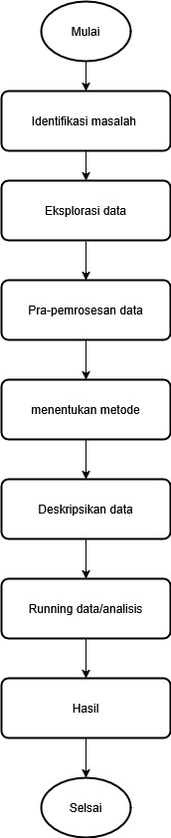
This study employed the Spatial Regression method, a statistical technique that considers spatial autocorrelation, or the influence that occurs between geographical regions. In this situation, the spatial regression method was chosen because cayenne pepper production in a district or city in West Nusa Tenggara (NTB) is likely influenced by production in surrounding areas. The model used was the Spatial Error Model (SEM), specifically designed to address spatial autocorrelation in regression model errors.

Figure 1. Research Flow Diagram
The analytical methods applied in this study can be explained through the following steps:
- Data collection was carried out using secondary data from the West Nusa Tenggara Provincial Agriculture Office in 2024, covering ten regencies or cities.
- The data was explored and analyzed in depth to determine the distribution of production across various regions, which was then visualized in graphs and thematic maps (choropleths) using ArcView.
- Spatial autocorrelation testing was performed using the Global Moran's Index to examine overall spatial patterns, and the Local Moran's Index (LISA) to identify areas exhibiting significant spatial patterns.
- The LM Error Test was conducted to identify whether there was spatial dependence in the OLS model errors, which will form the basis for selecting a spatial regression model.
- SEM model parameters were calculated to assess the impact of harvested area and productivity on cayenne pepper production, while taking into account autocorrelation in spatial errors through the lambda coefficient (λ).
- After the SEM model is formed, classical assumptions are tested, including residual normality, residual variance homogeneity, and freedom from multicollinearity among independent variables.
- Evaluation is conducted by comparing the SEM model with the classical linear regression (OLS) model based on the main criterion, namely the Akaike Information Criterion (AIC).

Result and Discussion

The 2024 cayenne pepper production chart in West Nusa Tenggara Province shows significant imbalances between regions. East Lombok leads the pack with production reaching over 650,000 quintals, far exceeding that of other regencies or cities. Meanwhile, regions such as North Lombok, Bima, and Sumbawa recorded medium-level production, while other regions, such as Mataram City, Bima City, and West Sumbawa, showed very low levels. This unevenness reflects variations in land conditions, productivity levels, and economic focus across regions and can be taken into consideration in formulating regional agricultural development policies.

Figure 2. Production of Cayenne Pepper in 2024
Chili pepper production in West Nusa Tenggara Province in 2024 showed an influence from surrounding areas. This is evidenced by the global and local Moran's index values. Although the global Moran's index of -0.111 with a p-value of 0.052000 (below α=10%) statistically indicates positive spatial autocorrelation, local analysis yields a different conclusion.
Globally, cayenne pepper productivity in NTB exhibits spatial autocorrelation. However, when viewed locally, the results differ. Based on local Moran's index values, ten regions showed significance at an error level of α=10%. These regions are West Lombok Regency, Central Lombok, East Lombok, Sumbawa, Dompu, Bima, West Sumbawa, North Lombok, Mataram City, and Bima City. These ten regions were then grouped into four distinct quadrants using a Moran scatterplot, the results of which are shown in Figure 4.
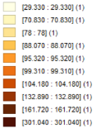
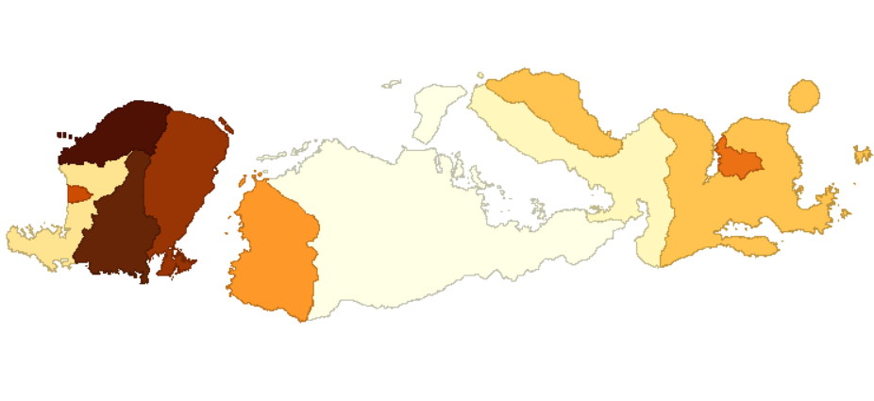
Figure 3. Thematic Map of Chili Pepper Productivity in Each City/Regency
Chili pepper productivity in West Nusa Tenggara Province in 2024 showed an influence from neighboring regions. This is evident through Moran's index analysis, both at the global and local scales. The global Moran's index of -0.111 with a p-value of 0.052000 (less than α=10%) indicates a fairly strong positive spatial autocorrelation. This means that regions with high chili pepper productivity tend to contribute to high productivity in their surroundings, and vice versa for regions with low productivity.
However, when examined more closely at the local level, the Moran's analysis yields a different conclusion. The local Moran's index identified one significant region and nine potential regions out of ten observed regions, with an error margin of α=10%. These ten regions were then categorized into four distinct quadrants, as shown in the Moran's Scatter Plot in Figure 4.
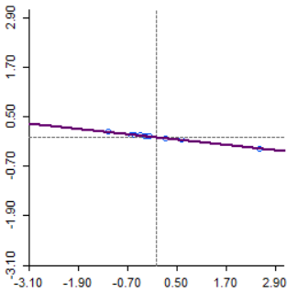
Figure 4. Moran Planning Plot of Chili Pepper Productivity

Visualization of the ten significant regions, divided into four Moran quadrants: High-High, Low-Low, Low-High, and High-low. The High-High, Low-Low, Low-High, and High-low quadrants are each filled by one significant district/city, namely Sumbawa Regency, which indicates high productivity in the area. This condition has the potential to affect the stability of the quality or production of cayenne pepper in the surrounding area if not handled properly. Conversely, Sumbawa Regency, which is shown in (blue), is actually in the Low-High quadrant, which means that cayenne pepper productivity in the region is low. For now, insignificant regions (at α = 10%) are marked in gray.
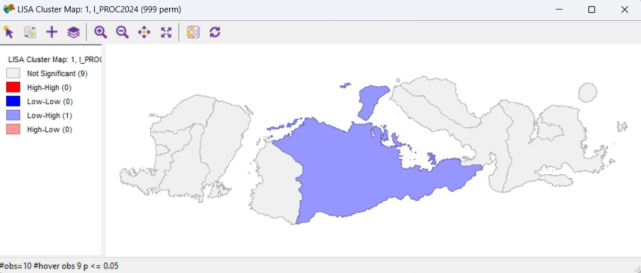
Figure 4. Thematic Map Based on Local Moran's Test

Based on the Spatial Error Model (SEM) regression output you provided, the resulting formula is as follows: y^ = -3.92556e+06+ 1.66667Wy + 96.6132X1 + 44385.5X2
The results of the SEM model estimation and testing can be seen in Table 2. From these results, two explanatory variables were obtained with probability values ​​less than α=10%.
This indicates that both explanatory variables have a significant effect on the productivity of cayenne pepper in West Nusa Tenggara at a significance level of 10%. The two significant explanatory variables found are: Harvested Area of ​​Cayenne Pepper (X1) and Productivity of Cayenne Pepper (X2). In addition to these two significant explanatory variables, there is also a new significant coefficient, namely . The resulting SEM model is considered appropriate because it meets all the assumptions of classical linear regression, namely, normally distributed residuals, homogeneous residual variances, and independent residuals.
Table 2. Testing and Estimation of SEM Model Parameters
Predictor | Coefficient | Z | p
Constant | -3.92556e+06 | -3.49926 | 0.00047
Harvested Area X¹ | 96.6132 | 40.1092 | 0.00000
Productivity X² | 44385.5 | 6.71218 | 0.00000
Lambda | 1.66667 | 3.14447 | 0.00166

The positive coefficient of X¹ (Harvested Area) of 96.6132 indicates that increasing the area of ​​land used to grow cayenne peppers in an area will also increase cayenne pepper production. Similarly, the positive coefficient of X² (Productivity) of 44385.5 indicates that each unit increase in cayenne pepper productivity leads to a significant increase in total production. This indicates that both factors play a significant role in determining the amount of cayenne pepper production in a given area.
The criteria used to select the best model is to compare the AIC values. A comparison between SEM and classical linear regression can be seen in Table 3.
Table 3. Comparison of the goodness-of-fit measures of the SEM and OLS models
Model | AIC
Classical linear regression (OLS) | 318.202
Spatial regression (SEM) | 316.58

Based on the Model is considered better if it has a smaller Akaike Information Criterion (AIC) value. Based on the Model Comparison Table, the Classical Linear Regression Model has a larger AIC value (318.202) when compared to the SEM Model which has a smaller AIC value (316.58). based on the comparison results the SEM Model has a lower AIC value in Classical Linear Regression indicating that this SEM model is better than the OLS model. Therefore, based on this criterion, the Spatial Error Regression model is better for modeling cayenne pepper productivity in West Nusa Tenggara Province.

Conclusion

Based on the analysis conducted using the spatial regression method through the Spatial Error Model (SEM) approach, a model was obtained that meets basic statistical assumptions, where the residual values ​​are normally distributed, the residual variance is consistent, and there is no multicollinearity. The SEM model indicates that the harvested area and cayenne pepper productivity have a significant impact on total production at a 10% significance level, with an AIC value of 316.58, indicating that this model can explain production differences very well and effectively compared to the classical linear regression model. The analysis findings also revealed positive spatial autocorrelation between regions, indicating that production in one district or city is influenced by the conditions of the surrounding area. Therefore, the formulation of agricultural sector development policies must consider a region-based approach. In future research, it is recommended to add other variables such as rainfall, soil quality, and technology use, as well as consider the application of more complex spatial models or machine learning methods to improve the accuracy and clarity of the analysis results.

References
Deviani, F., Rochdiani, D., & Saefudin, B. R. (2019). Analisis Faktor-Faktor Yang Mempengaruhi Produksi Usahatani Buncis Di Gabungan Kelompok Tani Lembang Agri Kabupaten Bandung Barat. Agrisocionomics: Jurnal Sosial Ekonomi Pertanian, 3(2), 165–173. https://doi.org/10.14710/agrisocionomics.v3i2.6099
Dupayana, I. P. W., & Anang, Y. (2024). Pembangunan Sistem Informasi Manajemen Agenda Kegiatan Berbasis Web di BPS Provinsi Nusa Tenggara Barat (Development of a Web-Based Activity Agenda Management Information System at Statistics of Nusa Tenggara Barat Province). 499–510.
Fadli, F., Nursan, M., & Yusuf, M. (2024). Analisis Efisiensi Usahatani Cabai Rawit Di Kecamatan Suralaga Kabupaten Lombok Timur. Prosiding SAINTEK, 6(November 2023), 110–118. https://doi.org/10.29303/saintek.v6i1.925
Febrilia, B. R. A., Sari, N. M. W., Danasari, I. F., & Vijaya, N. P. S. A. (2023). Analisis Faktor-Faktor yang Mempengaruhi Produksi Cabai Rawit di Kecamatan Kediri Kabupaten Lombok Barat. Agrifo : Jurnal Agribisnis Universitas Malikussaleh, 8(2), 10. https://doi.org/10.29103/ag.v8i2.12560
Manggala, R. B., & Boedi, A. (2018). Faktor-Faktor Yang Mempengaruhi Produksi Padi Di Desa Sumengko Kecamatan Sukomoro Kabupaten Nganjuk. Jurnal Ilmu Ekonomi, 2, 441–452.
Mantja, K., Haring, F., Mahendra, W. Y., Syam’un, E., Asrul, L., Sahur, A., & Ridwan, I. (2020). Growth and Production of Cayenne Pepper (Capsicum Frutescens L.) on Various Concentrations of Bio-Fertilizer and NPK Fertilizer. IOP Conference Series: Earth and Environmental Science, 575(1), 012109. https://doi.org/10.1088/1755-1315/575/1/012109
Mar’ah, Z., Nabila, A., & Ruslan. (2025). Penerapan Spatial Error Model (SEM) Dalam Menganalisis Faktor-Faktor Yang Mempengaruhi Stunting Balita Di Indonesia Application Of Spatial Error Model (SEM) In Analyzing Factors Affecting Stunting In Indonesia. Jurnal EKSPONENSIAL, 16(1), 41–45. https://doi.org/10.30872/eksponensial.v16i1.1465
Murakami, J., & Kato, H. (2020). The intra-metropolitan distribution of airport accessibility, employment density, and labor productivity: Spatial strategy for economic development in Tokyo. Applied Geography, 125(July), 102309. https://doi.org/10.1016/j.apgeog.2020.102309
Nisa, A., & Ambarwati, E. (2022). Keragaman Morfologi Bunga dan Buah Dua Puluh Aksesi Cabai (Capsicum sp.). Vegetalika, 11(4), 280. https://doi.org/10.22146/veg.63923
Nur Wahyu Riska Febriana, & Hailuddin. (2024). Analisis Pengaruh Kesetaraan Gender di Bidang Kesehatan, Pendidikan, danEkonomi terhadap Pertumbuhan Ekonomi Nusa Tenggara Barat. Nusa Tenggara Barat, 5(5), 1034–1044. http://doi.org/10.36418/syntax-imperatif.v5i5.526
Nurjanah, N., Rinaldi, A., & Putri, R. (2023). Spatial Error Model Pada Tingkat Kemiskinan Kabupaten/Kota Di Provinsi Lampung. VARIANCE: Journal of Statistics and Its Applications, 5(1), 47–54. https://doi.org/10.30598/variancevol5iss1page47-54
Postiglione, P., Cartone, A., & Panzera, D. (2020). Economic convergence in EU NUTS 3 regions: A spatial econometric perspective. Sustainability (Switzerland), 12(17). https://doi.org/10.3390/SU12176717
Preciosa, Y. N., Sariyoga, S., & Sari, R. M. (2019). Dampak Kebijakan Penetapan Harga Acuan Terhadap Volatilitas Harga Cabai Besar Di Indonesia. Jurnal Agribisnis Terpadu, 12(1), 59. https://doi.org/10.33512/jat.v12i1.5535
Rizki, L. Y., Silvana, N., Huda, T. N., Utami, K. J., & Saksono, H. (2024). Transformasi Bisnis Komoditas Cabai di NTB: Analisis Disparitas Pertumbuhan Cabai Merah dan Cabai Rawit 2013–2022. Aletheia: Jurnal Sosial & Humaniora, Inovasi, Ekonomi, Dan Edukasi, 1(2), 105–116. https://doi.org/10.63892/aletheia.1.2024.105-116
Safitri, I. Y., Tiro, M. A., & Ruliana. (2022). Spatial Regression Analysis to See Factors Affecting Food Security at District Level in South Sulawesi Province. ARRUS Journal of Mathematics and Applied Science, 2(2), 60–72. https://doi.org/10.35877/mathscience740
Septiadi, D., & Joka, U. (2019). Analisis Respon dan Faktor-Faktor yang Mempengaruhi Permintaan Beras Indonesia. AGRIMOR, 4(3), 42–44. https://doi.org/10.32938/ag.v4i3.843
Setyo, R., Ahmadi, N. U. R., Studi, P., Industri, T., Teknik, F., & Surakarta, U. M. (2003). Respon Pemberian Pupuk MKP dan Jarak Tanam Terhadap Pertumbuhan dan Produksi Cabai Rawit (Capsicum frustescens L.). 147–173.
Siswanto, Y., Lubis, Z., & Akoeb, E. N. (2020). Analisis Faktor-Faktor yang Mempengaruhi Produksi Kelapa Sawit Rakyat di Desa Tebing Linggahara Kecamatan Bilah Barat Kabupaten Labuhanbatu. AGRISAINS: Jurnal Ilmiah Magister Agribisnis, 2(1), 60–70. https://doi.org/10.31289/agrisains.v2i1.255
Yusuf, M., & Septiadi, D. (2024). Efisiensi Penggunaan Faktor Produksi Pada Usahatani Cabai Rawit Di Kecamatan Sakra Kabupaten Lombok Timur. AGRITA (AGri), 6(1), 63. https://doi.org/10.35194/agri.v6i1.4225

